14 July 2021



**Headteacher:**

Dr R P Petrie BSc PhD

Dear Parent / Carer

We write to you to inform you that GCSE results day this year is **Thursday 12 August**. Doors will open at 08:30 for Year 11. With Covid mitigations and student confidentiality in mind it is only students who are permitted in the building to collect results. Full pastoral support will be available for students on this day.

As you are well aware the process of assessing and grading this year has been very different. Consequently the appeals process is also unique to this year. The appendix attached to this letter takes you through many Frequently Asked Questions relating to appeals.

* The deadline for appeals to school is **08:00, 3 September**. Appeals must be sent to [examappeals@cockermouthschool.org](mailto:examappeals@cockermouthschool.org).

All of this information is also on our Firefly page <https://cockermouth.fireflycloud.net/teacher-assessed-grades-2021/appeals>. In addition Dr Henley has made a short video guide which can be found here <https://www.loom.com/share/1834c1753b4843f68bb306bed8bf4027> and on our Firefly pages.

Any student who is not able to attend their results day, (e.g. self-isolating, on holiday), must provide one the following:

* Written permission to email out results to a named email address given to the Exams Officer. This can either be a handwritten note or an email from the student’s school email address.
* A written permission note from the student given to a nominated person to collect results on behalf of the student.
* A stamped addressed envelope given to the Exams Officer with written permission to post results out.

We are unable to give results out to anybody other than the intended student without one of these forms of permission. No results will be given out over the phone.

Finally, we should make you aware that any student wishing to re-sit their examinations in the Autumn series must notify school by 08:00, 3 September. From results day there will be a form on Firefly. If you have any questions about this please contact the Exams Officer.

We look forward to seeing all of our students in August.

Yours sincerely

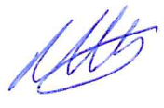

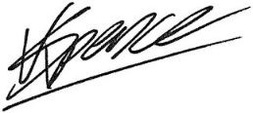

**Mr K Spence Dr M Henley**

**Exams Officer Deputy Headteacher**

*Encl. Frequently Asked Questions to Parents/Carers and Students about appeals*